**Create a multi-language question answering solution**

1. Has to be enabled on project creation
2. Create QA knowledge base in one language first
3. Test, train, perfect
4. Create new project in second language
5. Test, train, perfect
6. You will need to send users to the correct endpoint base on their language or Use the language detection API method to intercept the first question and determine language.

**Create project in German**

To be able to create a project in more than one language, the **multiple language setting** must be set at the creation of the first project that is associated with the language resource.

[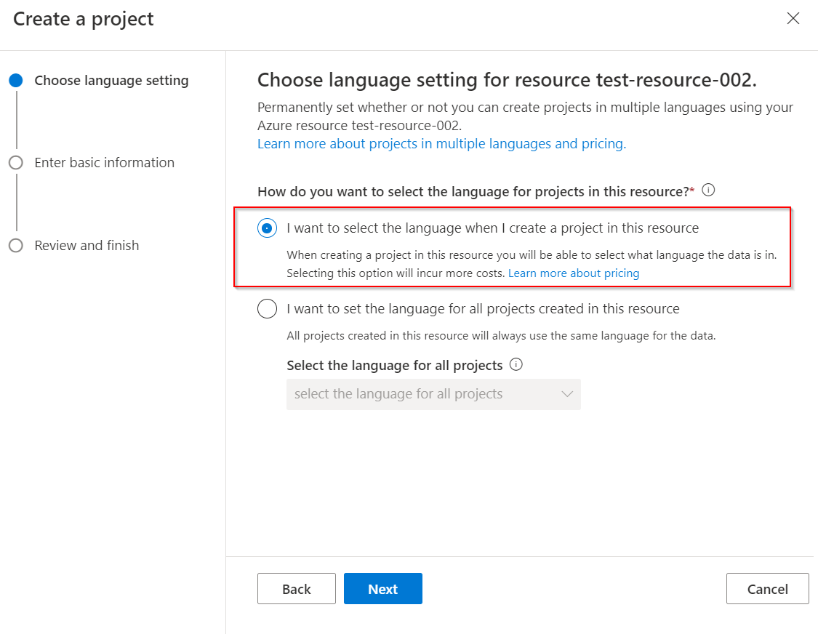](https://learn.microsoft.com/en-us/azure/ai-services/language-service/question-answering/media/multiple-languages/multiple-languages.png#lightbox)

1. From the [Language Studio](https://aka.ms/languageStudio) home page, select open custom question answering. Select **Create new project** > **I want to select the language when I create a project in this resource** > **Next**.
2. Fill out enter basic information page and select **Next** > **Create project**.

[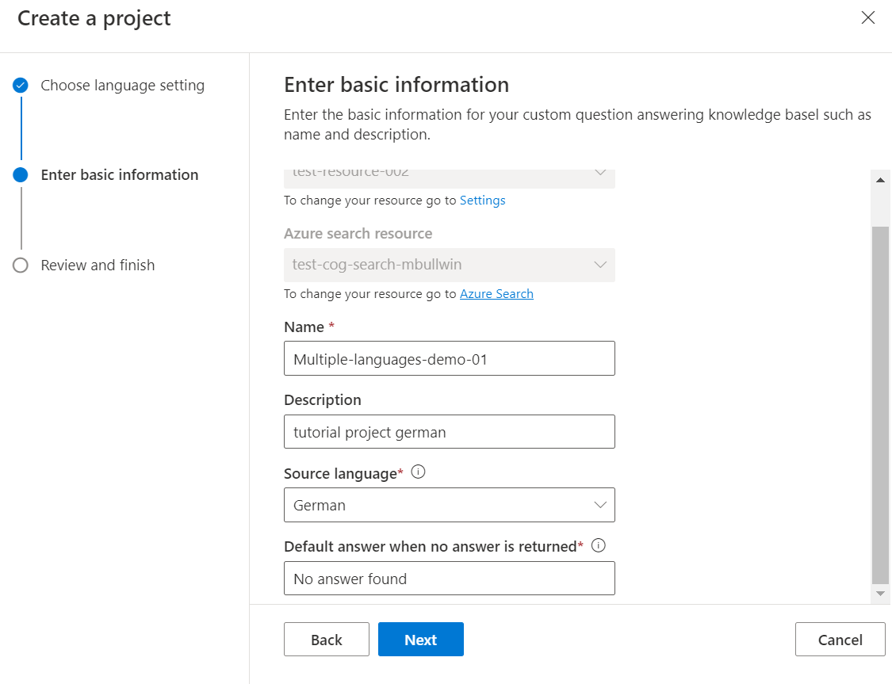](https://learn.microsoft.com/en-us/azure/ai-services/language-service/question-answering/media/multiple-languages/choose-german.png#lightbox)

1. **Add source** > **URLs** > **Add url** > **Add all**.

Custom question answering reads the document and extracts question answer pairs from the source URL to create the project in the German language. If you select the link to the source, the project page opens where we can edit the contents.

[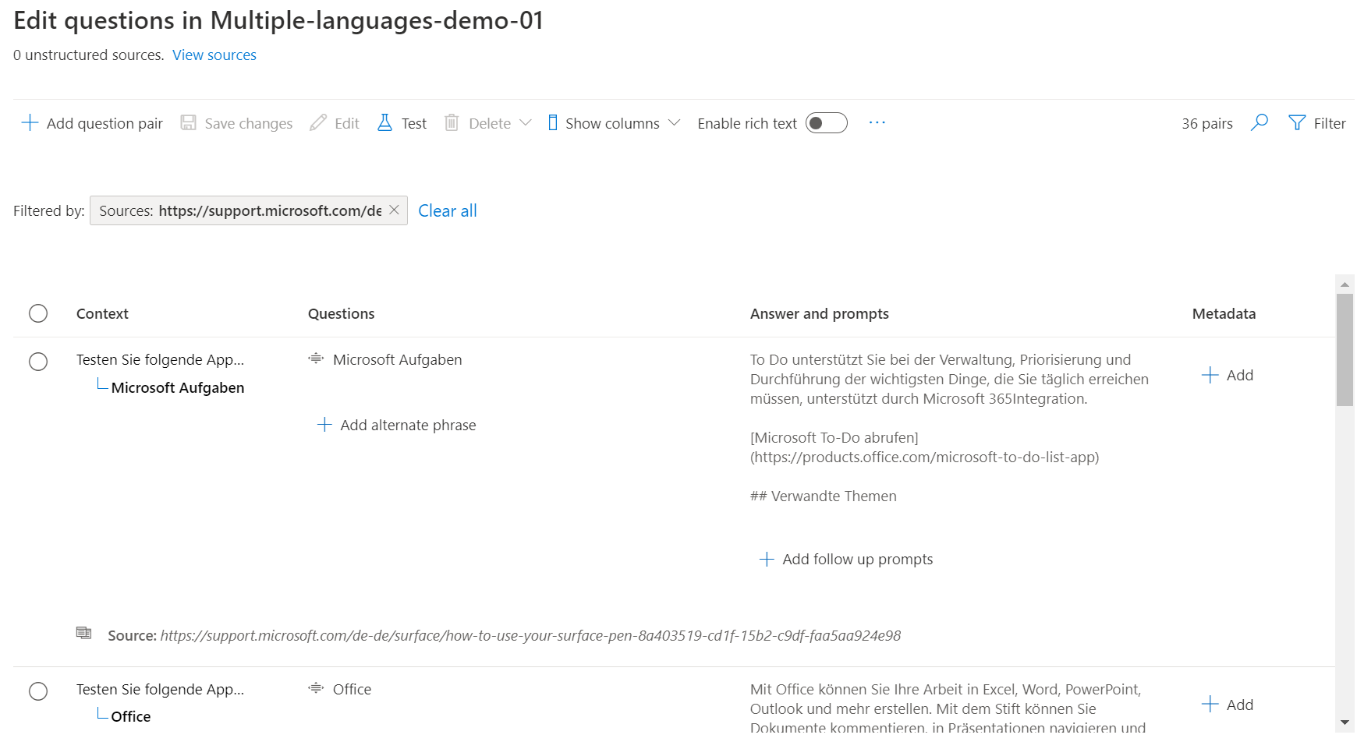](https://learn.microsoft.com/en-us/azure/ai-services/language-service/question-answering/media/multiple-languages/german-language.png#lightbox)

**Create project in English**

We now repeat the above steps from before but this time select English and provide an English URL as a source.

1. From the [Language Studio](https://aka.ms/languageStudio) open the custom question answering page > **Create new project**.
2. Fill out enter basic information page and select **Next** > **Create project**.

1. **Add source** > **URLs** > **Add url** > **Add all**.

**Deploy and query project**

We are now ready to deploy the two project and query them in the desired language using the custom question answering REST API. Once a project is deployed, the following page is shown which provides details to query the project.

[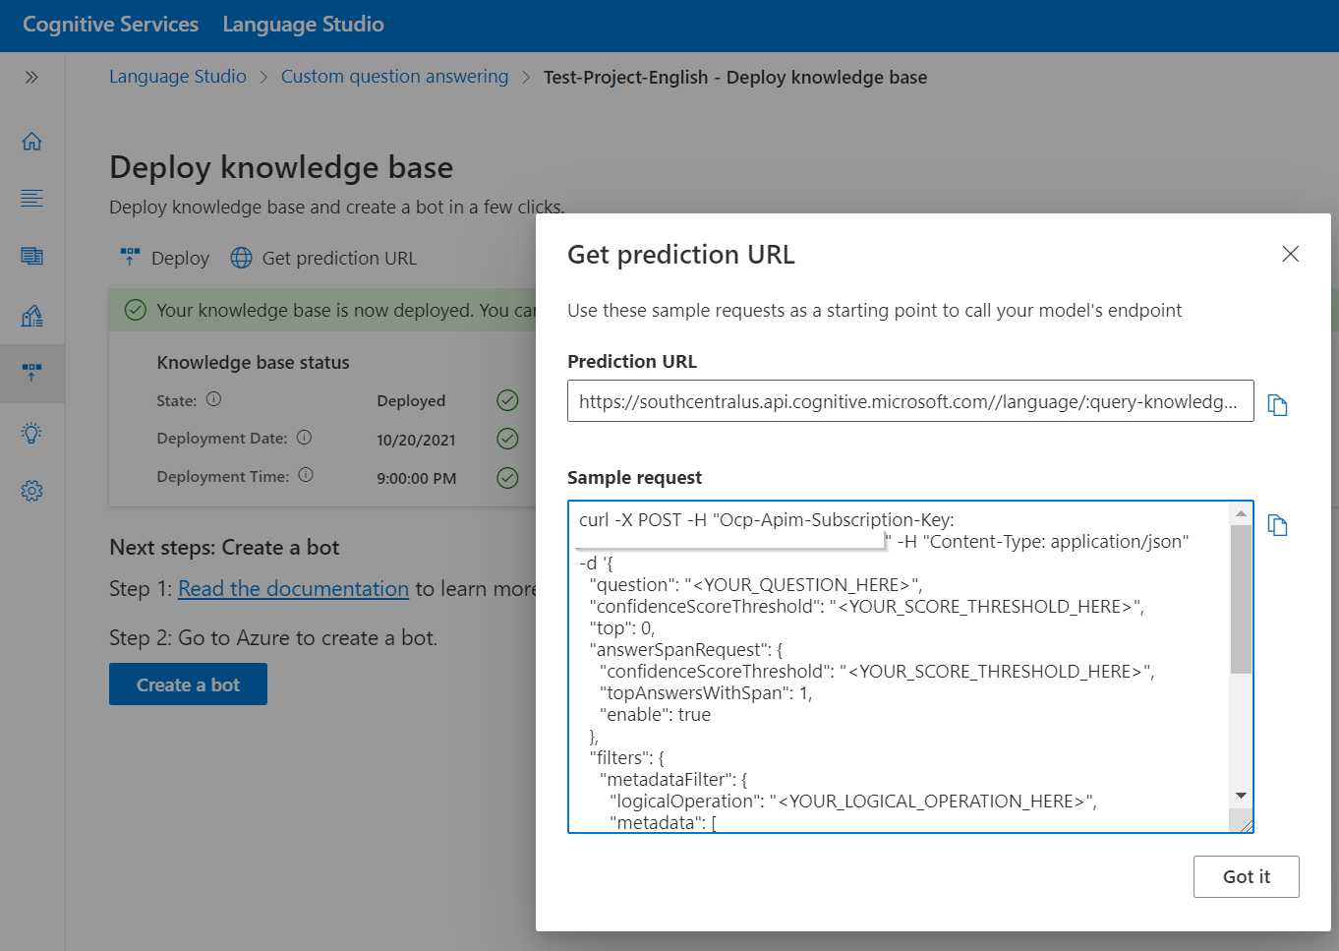](https://learn.microsoft.com/en-us/azure/ai-services/language-service/question-answering/media/multiple-languages/get-prediction-url.png#lightbox)

The language for the incoming user query can be detected with the [Language Detection API](https://learn.microsoft.com/en-us/azure/ai-services/language-service/language-detection/how-to/call-api) and the user can call the appropriate endpoint and project depending on the detected language.